Tahfizul Hasan Zihan (1921629)

Avijit Saha (1930109)

Md. Safiul Mujnebin (1921678)

S.M Farhan Shariar (1920408)

Afif Bin Arfan (1920153)

Suparna Sarkar Sapna (2021604)

**TEAM: FAILURE DATABEES**

Database management Project

STUDENTS PERFOMANCE MONITORING SYSTEM 4.0



# 

Contents

CHAPTER-I INTRODUCTION 2

BACKGROUND OF THE ORGANIZATION - IUB: 2

BACKGROUND OF THE PROJECT - SPMS 4.0: 2

OBJECTIVE OF THE PROJECT - SPMS 4.0: 2

SCOPE OF THE PROJECT: 3

CHAPTER-2 REQUIREMENT ANALYSIS 3

RICH PICTURE - EXISTING SYSTEM (SPMS 3.0): 3

Existing Processes along with Six System Element Analysis 5

EXISTING PROBLEMS & ANALYSIS OF THE PROBLEM 34

PROPOSED BUSINESS SYSTEM (WITH RICH PICTURE) 34

PROPOSED PROCESSES ALONG WITH SIX SYSTEM ELEMENT ANALYSIS 35

CH-3 LOGICAL SYSTEM DESIGN 69

BUSINESS RULES 69

A. ENTITY RELATIONSHIP DIAGRAM: 71

ENTITY RELATIONSHIP DIAGRAM TO RELATIONAL SCHEMA: 72

NORMALIZATION: 73

DATA DICTIONARY: 82

CHAPTER-4 PHYSICAL SYSTEM DESIGN 93

STARTUP PAGE: 93

Backlogged Student Data Entry Form 94

Backlogged Students Data Table: 95

Add exam data entry form: 95

PLO Analysis Spider Chart: 96

Plo Analysis with Department Average Bar Chart: 97

Code For Backlogged Data Retrieving from CSV And Inserting Into Section Table, Registration Table & Student Course Performance Table For Updating PLO, CLO Analysis: 97

Code for Showing Backlogged Data Table: 99

CHAPTER-5 CONCLUSION 100

PROBLEM AND SOLUTION: 100

Analysis Phase: 100

Design Phase: 100

Implementation Phase: 100

Additional Features and Future Development: 100

Conclusion & Recommendations 100

# CHAPTER-I INTRODUCTION

## BACKGROUND OF THE ORGANIZATION - IUB:

IUB is a private university in Bangladesh which was established in 1993. It has a current enrollment of around 10 000 at undergraduate and graduate levels. More than 450 highly qualified and highly skilled faculty members who are exceptionally good at their department of teaching and where at least half of them are PhD degree holders. IUB also has an alumni strength of nearly 14000 people. There are currently 5 academic schools in IUB.

1) School of Business & Entrepreneurship

2) School of Engineering, Technology and Sciences

3) School of Environment & Life Sciences

4) School of Liberal Arts & Social Sciences

5) School of Pharmacy and Public Health

## BACKGROUND OF THE PROJECT - SPMS 4.0:

Student Performance Monitoring System (SPMS 3.0) is a framework for Outcome-Based Education (OBE). It evaluates the performance of students, course instructors, schools, departments and programs and helps the Higher Authorities of the education institution to make strategies for improvements.

## OBJECTIVE OF THE PROJECT - SPMS 4.0:

SPMS 4.0 monitors and analyzes the performance of its stakeholders such as Students, Course instructors, Departments, Schools, Programs through the database of assessments such as quizzes, midterm exams, final term exams etc. In order to evaluate the performance of the stakeholders, SPMS 4.0 stores necessary documents and data in the database such as all the exam question papers, answer scripts, course outlines and marks of the exams and assessments with respect to their Course Outcomes (CO), Program Learning Outcomes (PLO) and Program Outcomes (PO) achieved by the students. Hence, students can statistically monitor their own performance. SPMS 4.0 also creates opportunities for Higher Authorities to draw conclusions and make further improvements by providing them with a wide range of analytical reports based on the performance of students, course instructors, departments, schools, and programs.

## SCOPE OF THE PROJECT:

We have done a complete analysis of the existing system (SPMS 2.0) and identified some issues in the business processes which can cause the process to become slow, inefficient and cause lapses in communication.

The proposed solution to overcome those issues is to create a more improved version of the system called SPMS 3.0 (Student Performance Monitoring System 3.0) which uses a Relational Database Management System (RDBMS) to store, update and retrieve necessary documents such as Course Outlines, Exam Question Papers and Answer Scripts as well as other necessary data required to monitor student performance and produce other OBE (outcome-Based Education) reports.

We have identified all the users of the system (SPMS 3.0), how they would be accessing the necessary data and information and how they would interact with each other etc.

We aim to develop interfaces that allow all users to access new data fields in the existing web application. These data fields will capture information such as Student ID, Educational year, Educational semester, Enrolled course, Enrolled section, and Obtained grade. Users will have the option to input data manually through a form or import data from a CSV file, which will be extracted and inputted into the database.

Additionally, we are implementing a new feature that calculates the course outcome percentage based on the obtained grades for each course. This calculated percentage will be displayed to both students and faculty members through the web application.

# CHAPTER-2 REQUIREMENT ANALYSIS

Requirement Analysis is the process of determining what the database is used for. It involves interviews with stakeholders in order to identify the functionality and system requirements they expect and require from the database, what operations need to be performed and what data they need to process. By doing so, we can get a proper understanding of the stakeholders and how they interact with each other.

## RICH PICTURE - EXISTING SYSTEM (SPMS 3.0):

A rich picture is a way to demonstrate processes in a system which is easier to understand for everyone. It consists of pictures, text, symbols and icons which are all used to illustrate graphically the situation. [3] A rich picture helps us to see relationships. and connections that we may otherwise miss [3]. It helps identifying one or more themes participants may want to further explore and address. Rich pictures are therefore always used in the pre-analysis phase [3].

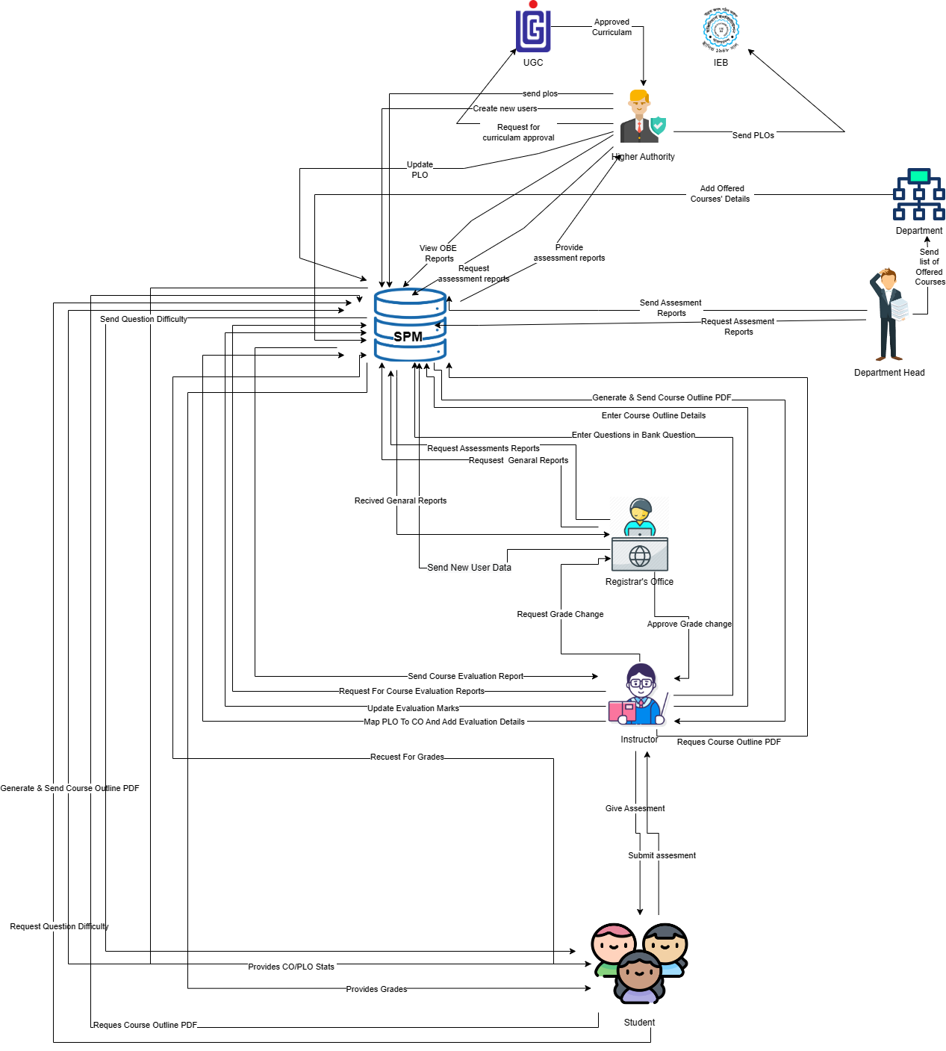

In this rich picture the stakeholders are:

1) IUB

2) IEB

3) Higher Authority (VC, Dean etc)

4) Department Head

5) Department Office

6) SPMSV 3.O Department Head (SPMS Manager)

7) Registers Office

8) Faculty

9) Student

The Main Storages are

1) SPMS V2.o

2) Physical Storage (Used by the faculty)

## Existing Processes along with Six System Element Analysis

The six elements analysis of the proposed system is a continuation of an analysis process where each analysis is based on the one that comes before it. Based on the rich picture, the role of each element in the new system is further understood in the table below

|  |  |  |  |  |  |  |
| --- | --- | --- | --- | --- | --- | --- |
| Process | System Roles | | | | | |
| Human | Non-Computing Hardware | Computing Hardware | Software | Database | Network and Communication |
| Student Enrollment | Student:  a) Search for the website  b) Goes to the website.  c) Clicks  on the  form  option.  c) Fill up the  form with  required  Information.  Department Head :  a) Department Head  logs into  the system  using  SPMS  User-ID and  password.  b)  Receives  the student  enrollment information in the  attached  files.  c) Department Head  updates the  student  enrollment information in  Database.  d) Inputs  the desired  time  period for  number of  students  enrolled. | Paper and Stationery:  a) Used to collect information about students through enrollment forms. | Computer/  Laptop  a) SPMS Department Head will use Computers to access and update data.   b) Users will use the  computer to view the data.  Database  Server  a) Used by  SPMS  Developers to collect data and maintain the software.  Networking Devices  (Router,  Switch,  Bridge, Hub):  a) Used to  access SPMS | Operating  Software  a) Utilized by  Registrar  Office and  SPMS  Student  a) Uses to fill  up the form  from the  website.  SPMS  a) The software for which the Department Head istrator will set up user accounts. | Register  Office  Database  a) Used by the registrar's office to compile student data into an excel file for sending to SPMS.  SPMS  a) For any upgrades or new user accounts, information is kept in the database.  Excel  a) Data from student accounts may be kept in an excel file and used later in SPMS. | Internet  a) To access and store data to SPMS it is used.  b) It is used to collect the student form from the student to registrar office.  c)The Registrar office sends all the student information to SPMS Department Head by using it. |
| Student Performance Based on CGPA | Student:  a) Logs into  the System  using  Student-ID  and  password.  b) Inputs the desired time - period to  view self  CGPA  Progress.  Department Head :  a) Logs into  the System  using User-ID  and  password.  b) Inputs the  desired time  period and  School,  Department or program to view  Statistically and analyzed  CGPA trend  of students.  Faculty:  a) Logs into the system  using  Faculty-ID  and  password.  b) Inputs the  desired time  -period and  program to view  statistically and  analyzed  CGPA trend  of students or any  individuals student those  who attended  the faculty’s  Section. |  | Computer/  Laptop  a)User will need a computer to access SPMS  Printer  a)Used to print out the report if need be.  Networking Devices  (Router,  Switch,  Bridge, Hub):  a)Used to  access the  Internet. | Operating  Software  a) The user uses it to execute SPMS 2.0  SPMS  a) A performance trend will be generated by the software. | SPMS  Database  a) Obtain performance using the database. | Internet  a) To login into and access the SPMS it is used. |
| Course-wise student performance based on CGPA | Student:  a) Logs into the system  using  Student-ID  and  password.  b) Inputs the  course  c) View self  GPA for the  course. **Department Head :**  a) Logs into the System  using User-ID and  password.  b) Inputs the desired time-  period  Course-ID  c) View statistically analyzed  GPA trend of  Students.  Faculty:  a) Logs into the System  using  Faculty-ID  and  password.  b) Inputs the  desired time  -  period  Course-ID  under the  faculty  c)view  statistically analyzed  GPA trend of  students who faculty’s  section. |  | Computer/  Laptop  a)User will need a computer to access SPMS  Printer  a)Used to print out the report if need be.  Networking Devices  (Router,  Switch,  Bridge, Hub):  a)Used to  access the  Internet. | SPMS  a) A performance trend based on GPA will be generated by the software. | SPMS  Database  a) Here, the performance will be stored and updated. | Internet  a) To login into and access the SPMS it is used. |
| Selective Number of Instructor-wise student performance based on the GPA | Department Head :  a) Logs into the system  using User-ID and  password.  b) Inputs the  desired time-  period  Course-ID  c)View  statistically  analyzed  GPA trend of  students for a  selective  number of  Instructors.  Faculty:  a) Logs into the system  using  Faculty-ID  and  password.  b) Inputs the  desired time -  period &  Course-ID  c)View  statistically  analyzed  GPA trend of  students for a  selective  number of  Instructors.  GPA trend of  students for a  selective  number of  Instructors. |  | Computer/  Laptop  a)User will need a computer to access SPMS  Printer  a)Used to print out the report if need be.  Networking Devices  (Router,  Switch,  Bridge, Hub):  a)Used to  access the  Internet. | SPMS  a) a) The software will produce a performance trend for a specified instructor. | SPMS  Database  a) Here, the performance will be stored and updated. | Internet  a) To login into and access the SPMS it is used. |
| Department Head wise student performance | Department Head :  a) Logs into the system  using User-ID  and  password.  b) Select  Input from  from  VC/Dean/Department  Head  c) View the  student  performance  trend as per  choice. |  | Computer/  Laptop  a)User will need a computer to access SPMS  Printer  a)Used to print out the report if need be.  Networking Devices  (Router,  Switch,  Bridge, Hub):  a)Used to  access the  Internet. | SPMS  a) The software will produce a performance trend | SPMS  Database  a) Here, the performance will be stored. | Internet  a) To login into and access the SPM it is used. |
| Instructor-wise student performance based on the GPA of the students | Department Head :  a) Logs into the system  using  Department-I  D and  Password. b) Inputs a  particular  instructor  Name/ID  c)View the  student  performance  trend of  selected  Instructor.  Faculty:  a) Logs into the system  using User-ID and  password.  b) Input their  Name/ID.  c) View the  student  performance  trend. |  | Computer/  Laptop  a)User will need a computer to access SPMS  Printer  a)Used to print out the report if need be.  Networking Devices  (Router,  Switch,  Bridge, Hub):  a)Used to  access the  Internet. | SPMS  a) The software will produce a performance trend | SPMS  Database  a) The  performance  will be stored  and updated  in the  database. | Internet  a) To login into and access the SPM it is used. |
| Total PLO percentage achieved and attempted by the student along with the departmental average | Student:  a) Logs into the system  using Student-ID and  Password  b) Inputs the  time- period  c)Views their  comparison  of attempted  vs achieved PLO  percentage  along with  the  departmental  Average.  Department Head :  a) Logs into the system  using User-ID and  Password  b) Inputs the time- period  c) Views the comparison of students  attempted  PLO vs  achieved  PLO  percentage  along with  the  departmental  average.  Faculty:  a) Logs into the system  using User-ID and  Password.  b) Inputs the  time period.  c) Views the  comparison of students  attempted  PLO vs  achieved  PLO  percentage  along with  the  departmental  Average. |  | Computer/  Laptop  a)User will need a computer to access SPMS  Printer  a)Used to print out the report if need be.  Networking Devices  (Router,  Switch,  Bridge, Hub):  a)Used to  access the  Internet. | Operating  system  a) Used by  the  SPMS  SPMS  a)A comparison of the attempted vs. achieved PLO as well as the departmental average will be produced by the software. | SPMS  Database  a) Here, the performance will be stored. | Internet  a) To login into and access the SPM it is used. |
| PLO achievement | Student:  a) Logs into the system  using  Student-ID  and  password. b) Selects  PLO  achievement  c) View PLO  Achievement.  Department Head :  a) Logs into the System  using user-ID  and  password.  b) Selects  PLO  achievement  c) View PLO  Achievement.  Faculty:  a) Logs into  the System  using  Faculty-ID and  password.  b) Selects  PLO  Achievement.  c) View PLO  Achievement. |  | Computer/  Laptop  a)User will need a computer to access SPMS  Printer  a)Used to print out the report if need be.  Networking Devices  (Router,  Switch,  Bridge, Hub):  a)Used to  access the  Internet. | SPMS  a) A PLO achievement will be generated by the software. | SPMS  Database  a) Here, the performance will be stored and updated. | Internet  a) To login into and access the SPMS it is used. |
| Expected PLO-achievement versus actual score (for course's, student’s,  Department’s, program’s or school’s) | Student:  a) Logs into the system  using  Student-ID  and  password.  b) Selects  PLO  achievement  comparison  c) View PLO  achievement  Comparison.  Department Head :  a) Logs into the system  using user-ID  and  password.  b) Selects  PLO  achievement  comparison  c) View PLO  achievement  Comparison.  Faculty:  a) Logs into the System  using  Faculty-ID and  password.  b) Selects  PLO  achievement  comparison.  c) view PLO  Achievement comparison. |  | Computer/  Laptop  a)User will need a computer to access SPMS  Printer  a)Used to print out the report if need be.  Networking Devices  (Router,  Switch,  Bridge, Hub):  a)Used to  access the  Internet. | SPMS  a) A) The software will calculate the expected vs. achieved PLO. | SPMS  Database  a) The  performance  will be stored  and updated  in the  database. | Internet  a) To login into and access the SPMS it is used. |
| CO-PLO achievement summary | Student:  a) Logs into the system  using  Student-ID  and  password.  b) Selects  CO -PLO  achievement  summary.  c) View CO- PLO achievement summary.  Department Head :  a) Logs into the system  using user-ID  and  password.  b) Selects  CO -PLO  achievement  summary.  c) View CO  - PLO  achievement  Summary.  Faculty:  a) Logs into the system  using  Faculty-ID and  password.  b) Selects CO  -PLO  achievement  summary.  c) View CO  - PLO  achievement  Summary. |  | Computer/  Laptop  a)User will need a computer to access SPMS  Printer  a)Used to print out the report if need be**.**  Networking Devices  (Router,  Switch,  Bridge, Hub):  a)Used to  access the  Internet. | SPMS  a)The software will produce a summary of CO-PLO accomplishments. | SPMS  Database  a) The  Summary  will be stored  and updated  in the  database. | Internet  a) To login into and access the SPMS it is used. |
| Question Bank | Student:  a) Logs into the system  using  Student-ID  and  password.  b) Selects  Question Bank  c) Views form  d)Selects course, section and semester and assessment type.  d)Downloads questions  Faculty:  a) Logs into  the System  using  Faculty-ID and  password.  b) Selects  question bank  c) Views form  d)Selects course, section and semester and assessment type.  e) Uploads questions |  | Computer/  Laptop  a)User will need a computer to access SPMS  Printer  a)Used to print out the report if need be.  Networking Devices  (Router,  Switch,  Bridge, Hub):  a)Used to  access the  Internet | SPMS  a)The software will produce Question Bank | SPMS  Database  a) The  Question Bank  will be stored  and updated  in the  database | Internet  a) To login into and access the SPMS it is used. |
| Course Outline | Student:  a) Logs into the system  using  Student-ID  and  password.  b) Selects  Couse Outline  c) Views form  d)Selects course, section and semester.  d)Downloads course outline.    Faculty:  a) Logs into  the System  using  Faculty-ID and  password.  b) Selects  Course Outline  c) Views form  d)Selects course, section and semester.  e)Uploads course outline |  | Computer/  Laptop  a)User will need a computer to access SPMS  Printer  a)Used to print out the report if need be.  Networking Devices  (Router,  Switch,  Bridge, Hub):  a)Used to  access the  Internet | SPMS  a)The software will generate course Outline | SPMS  Database  a) The  Couse Outline will be stored  and updated  in the  database | Internet  a) To login into and access the SPMS it is used. |

## EXISTING PROBLEMS & ANALYSIS OF THE PROBLEM

|  |  |  |
| --- | --- | --- |
| Process Name | Existing System Problems | Proposed Solution |
| Developing a Customized Dashboard System | All users share the same dashboard. There is no feature allocation or role changes in each dashboard. Each user is not supposed to have every available feature. | Providing access to features and functionalities based on user roles. Developing a dynamic dashboard that only displays features and functionalities based on user roles. |
| Implementing Web Application Security Controls | All users can access every feature. Whether the webpage is linked or not, each user can access every page just by hitting URL. | Implementing authentication using PHP sessions, cookies, or other methods. |
| Implementing a Backlog Record Management System. | Backlogged records were unable to store. | Creating a new form to collect backlogged records of student’s grade or CLO, PLO data records |

## PROPOSED BUSINESS SYSTEM (WITH RICH PICTURE)

The enhanced system will enable users to access additional data fields within the existing web application, capturing details such as Student ID, Educational year, Educational semester, Enrolled course, Enrolled section, and Obtained grade. Users will have the flexibility to input data manually through a form or import data from a CSV file, which will be extracted and integrated into the database.

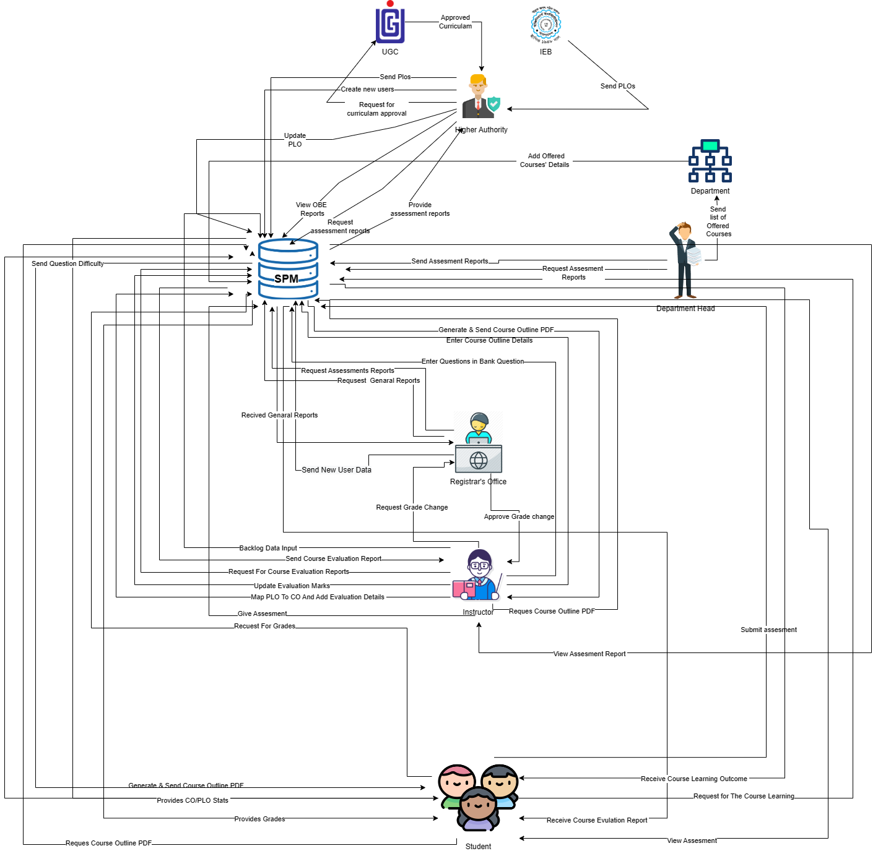

## PROPOSED PROCESSES ALONG WITH SIX SYSTEM ELEMENT ANALYSIS

The six elements analysis of the proposed system is a continuation of an analysis process where each analysis is based on the one that comes before it. Based on the rich picture, the role of each element in the new system is further understood in the table below.

|  |  |  |  |  |  |  |
| --- | --- | --- | --- | --- | --- | --- |
| Process | System Roles | |  |  |  |  |
| Human | Non-  Computing  Hardware | Computing  Hardware | Software | Database | Network and  Communication |
| Student Enrollment | Student:  Search for the  website  Goes to the website.  Clicks on the form | Paper and  Stationery:  a) Used to collect information about  students through enrollment forms. | Computer/  Laptop  a) SPMS Department Head will use  Computers to access and update data. | Operating  Software  a) Utilized by Registrar  Office and  SPMS    Student  a) Uses to fill | Register  Office  Database  a) Used by the registrar's office to  compile student data into an excel file for | Internet  To access and store data to SPMS it is used.    It is used to collect the student form from |

|  |  |  |  |  |  |  |
| --- | --- | --- | --- | --- | --- | --- |
|  | option.  c) Fill up the form with required  Information.    Department Head :  Department Head  logs into the system using  SPMS  User-ID and password.  Receives the student enrollment  information in the attached  files.  Department Head  updates the student enrollment  information in  Database.  d) Inputs the desired time period for number of students enrolled. |  | b) Users will use  the  computer to view the data.  Database  Server  a) Used by  SPMS  Developers to collect data and  maintain the software.    Networking Devices (Router,  Switch,  Bridge, Hub):  a) Used to access SP MS | up the form from the website.    SPMS  a) The software for which the  administrator will set up user accounts. | sending to SPMS.    SPMS  a) For any upgrades or new user  accounts, information is kept in the database.    Excel  a) Data from student accounts may be kept in an excel file and used later in SPMS. | the student to registrar office.    c)The Registrar office  sends all the student information to SPMS Department Head by using it. |

|  |  |  |  |  |  |  |
| --- | --- | --- | --- | --- | --- | --- |
| Student Performance Based on CGPA | Student:  Logs into the  System using  StudentID and password.  Inputs the desired |  | Computer/  Laptop  a)User will need a  computer to access SPMS    Printer  a)Used to print out | Operating  Software  a) The user uses it to execute  SPMS 2.0    SPMS  a) A performance trend will be | SPMS  Database  a) Obtain performance  using the database. | Internet  a) To login into and access the SPMS it is used. |

|  |  |  |  |  |  |  |
| --- | --- | --- | --- | --- | --- | --- |
|  | time period to view self CGPA  Progress. Department Head:   1. Logs   intothe  System using User-ID and password.   1. Inputs the desired time period and School,   Department or program to view  Statistically and  analyzed |  | the report if need be.    Networking Devices (Router,  Switch,  Bridge, Hub):    a)Used to access the  Internet. | generated by the software. |  |  |

CGPA

trend

of

students.

Faculty:

a)

Logs

the

into

system

using

Faculty

ID

and

password.

Inputs

b)

the

desired

time

-

period

and

program

to view

statistically

and

analyzed

CGPA

trend

|  |  |  |  |  |  |  |
| --- | --- | --- | --- | --- | --- | --- |
|  | of students or any individuals studet those who  attended the faculty’s Section. |  |  |  |  |  |
| Coursewise student performance based on CGPA | Student:   1. Logs into the systemusing   StudentID and password.   1. Inputs the course   c)View  self  GPA for  The |  | Computer/  Laptop  a)User will need a computer to access SPMS    Printer  a)Used to print out the report if need be.    Networking Devices (Router, | SPMS  a) A  performance trend based on GPA will be generated by the software. | SPMS  Database  a) Here, the performance will be stored and updated. | Internet  a) To login into and access the SPMS it is used. |

|  |  |  |  |  |  |  |
| --- | --- | --- | --- | --- | --- | --- |
|  | password.  b) Inputs the desired time  -  period Course-ID under the faculty  c)view  statistically analyzed  GPA trend  of students who  faculty’s section. |  |  |  |  |  |
| Selective  Number of  Instructor wise student performance based on the  GPA | Department Head :  a) Logs into the system using User-ID and password. |  | Computer/  Laptop  a)User will need a  computer to access SPMS | SPMS  a) a) The software will produce a  performance trend for a specified instructor. | SPMS  Database  a) Here, the performance will be stored and updated. | Internet  a) To login into and access the SPMS it is used. |

|  |  |  |  |  |  |  |
| --- | --- | --- | --- | --- | --- | --- |
|  | b) Inputs the desired time- period Course-ID  c)View  statistically analyzed  GPA trend  of students for a selective number of  Instructors  .    Faculty:  a) Logs into the system using  FacultyID and password. |  | Printer  a)Used to print out the report if need be.  Networkin g Devices (Router,  Switch,  Bridge, Hub):  a)Used to access the  Internet. |  |  |  |

b)

Inputs

the

desired

time

-

period &

Course

-

ID

c)View

statisticall

y

analyzed

GPA trend

of

students

for a

selective

number of

Instructors

.

GPA trend

of

students

for a

selective

number of

Instructors

.

|  |  |  |  |  |  |  |  |  |
| --- | --- | --- | --- | --- | --- | --- | --- | --- |
| Department Head wise student performance  Instructor  Wise student performance based on the GPA of the students | Department Head :   1. Logs into the systemusing User-ID and password. 2. Select Input from from   VC/Dean/ Departme  nt  Head   1. View   the student performance  trend as per choice.  Department Head :    a) Logs  into the  system  using  Department-I  D and  Password.  b) Inputs a  particular  instructor  Name/ID  c)View  the  student  performance  trend of  selected  Instructor  Faculty:  a) Logs  into the  system  using  User-ID  And password.  b) Input  their  Name/ID.  c) View  the  student  performance trend. |  | Computer/  Laptop  a)User will need a  computer to access SPMS    Printer  a)Used to print out the report if need be.      Networkin g Devices (Router,  Switch,  Bridge, Hub):  a)Used to access the  Internet.  a)User will need a  computer to access SPMS    Printer  a)Used to print out the report if need be.    Networking Devices (Router,  Switch,  Bridge, Hub):  a)Used to access the  Internet. | SPMS   1. software will produce performance trend   SPMS  a) The software will produce a  performance trend | The  a | SPMS  Database  The performance will be stored and updated in the database  SPMS  Database  The performance will be stored and updated in the database |  | Internet   1. To login into and access the SPM it is used.   Internet  a) To login into and access the SPM it is used. |

|  |  |  |  |  |  |  |
| --- | --- | --- | --- | --- | --- | --- |
| Total PLO percentage achieved and attempted  by the  student along with the  departmen  tal average | Student:   1. Logs into the system using Student-   ID and Password   1. Inputs   the time- period  c)Views their  comparison of attempted |  | Computer/  Laptop  a)User will need a  computer to access SPMS    Printer  a)Used to print out the report if need be.      Networkin g Devices (Router, | Operating system  a) Used by the  SPMS    SPMS  a)A comparison  of the attempted vs. achieved  PLO as well as the  departmental average will be produced by the software. | SPMS  Database  a) Here, the performance  will be stored. | Internet  a) To login into and access the SPM it is used. |

|  |  |  |  |  |  |  |
| --- | --- | --- | --- | --- | --- | --- |
|  | vs achieved  PLO  percentage along with the  departmental  Average.    Department Head :   1. Logs into the system using User-ID and Password 2. Inputs the time- period   c)Views the comparison  of  d)students attempted PLO vs  achieved  PLO  percentage  along with  the  departmenal  average.  Registrar’  s office:  a) Logs  into the  system  using  User-ID  and  Password  b) Inputs  the timeperiod  c) Views  the  comparison  of students  Attempted  PLO vs  achieved  PLO  percentag  e  along with  the  departmen  tal average.  Faculty:  a) Logs  into the  system  using  User-ID  and  Password.  b) Inputs  the  time  period.  c) Views  the compariso  n of  students  attempted  PLO vs  achieved  PLO  percentag  e  along with  the  departmen  tal  Average.  Dean  a) Logs into  the system  using User  ID and  Password  b) Inputs  the time  period  c) Views  the compariso  n of  students  Attempted  PLO vs  achieved  PLO  percentag  e  along with  the  departmen  tal  average.  VC  a) Logs  into the  system  using  User-ID  and  Password.  b) Inputs the time period.  c) Views  the  comparison of  students  attempted  PLO vs  achieved  PLO  percentage  along with  the  departmental  average. |  | Switch,  Bridge, Hub):  a)Used to access the  Internet. |  |  |  |

|  |  |  |  |  |  |  |
| --- | --- | --- | --- | --- | --- | --- |
| PLO achievement | Student:  a) Logs into the systemusing  StudentID and password. b) Selects  PLO achievement  c) View PLO  Achievement.  c) View  PLO  Achievement.  Department Head:  a) Logs  into the  System  using  user-ID  and  password.  b) Selects  PLO  achievement  c) View  PLO  Achievement.  a) Logs  into the  system  using  user-ID  and password.  b) Selects  PLO  achievement.  c) View  PLO  Achievement.  Faculty:  a) Logs  into  the  System  using  Faculty-  ID and  password.  b) Selects PLO  Achievement.  c) View  PLO  Achievement.  Dean a) Logs  into  the  System  using  user-ID  and  password.  b) Selects  PLO  achievement.  c) View  PLO  Achievement.  VC  a) Logs  into the  system  using  user-ID  and  password.  b) Selects  PLO  achievement.  c) View  PLO  Achievement |  | Computer/  Laptop  a)User will need a  computer to access SPMS    Printer  a)Used to print out the report if need be.      Networking Devices (Router,  Switch,  Bridge,  Hub):  a) Used to  access the  Internet. | SPMS  a) A PLO  achievement  will be generated by the software. | SPMS  Database  a) Here, the performance will be stored and updated. | Internet  a) To login into and access the SPMS it is used. |

|  |  |  |  |  |  |  |
| --- | --- | --- | --- | --- | --- | --- |
| Expected  PLO achievement versus actual score (for course's, student’s,  Department’s,  program’s or school’s) | Student:   1. Logs into the system using   StudentID and password.   1. Selects   PLO achievement  comparison   1. View PLO achievement   Comparison. |  | Computer/  Laptop  a)User will need a  computer to access SPMS    Printer  a)Used to print out the report if need be.    Networkin g Devices (Router,  Switch,  Bridge, Hub):  a)Used to | SPMS  a) A) The software will calculate the expected vs.  achieved PLO. | SPMS  Database  a) The performance will be stored and updated in the database. | Internet  a) To login into and access the SPMS it is used. |

|  |  |  |  |  |  |  |
| --- | --- | --- | --- | --- | --- | --- |
|  | Department Head :  a)Logs into the system using user-ID and password.   1. Selects   PLO achievement  comparison   1. View PLO achievement   Comparison.    Faculty:  a) Logs into the System using |  | access the  Internet. |  |  |  |

|  |  |  |  |  |  |  |
| --- | --- | --- | --- | --- | --- | --- |
|  | FacultyID and password.   1. Selects   PLO achievement  comparison.   1. view PLO   Achievement  comparison. |  |  |  |  |  |

|  |  |  |  |  |  |  |
| --- | --- | --- | --- | --- | --- | --- |
| CO-PLO achievement  summary | Student:   1. Logs into the system using   StudentID and password.   1. Selects   CO -PLO |  | Computer/  Laptop  a)User will need a  computer to access SPMS    Printer  a)Used to print out the report if need be**.** | SPMS  a)The software will produce a summary of CO-PLO accomplishments. | SPMS  Database  a) The  Summary  will be stored and updated in the database. | Internet  a) To login into and access the SPMS it is used. |

|  |  |  |  |  |  |  |
| --- | --- | --- | --- | --- | --- | --- |
|  | achivement  summary.  c) View CO- PLO achievement summary.    Department Head :   1. Logs into the system using user-ID and password. 2. Selects   CO -PLO achievement  summary.   1. View CO   - PLO achievement  Summary. |  | Networkin g Devices (Router,  Switch,  Bridge, Hub):  a)Used to access the  Internet. |  |  |  |

|  |  |  |  |  |  |  |
| --- | --- | --- | --- | --- | --- | --- |
|  | Faculty:   1. Logs into the system using   FacultyID and password.   1. Selects CO -PLO achieveme   nt  summary.   1. View CO   - PLO achievement  Summary. |  |  |  |  |  |

|  |  |  |  |  |  |  |
| --- | --- | --- | --- | --- | --- | --- |
| Question  Bank | Student:  a) Logs into the system using |  | Computer/  Laptop  a)User will need a  computer | SPMS  a)The software will produce  Question  Bank | SPMS  Database  a) The  Question  Bank | Internet  a) To login into and access the SPMS it is used. |

|  |  |  |  |  |  |  |
| --- | --- | --- | --- | --- | --- | --- |
|  | StudentID and password.   1. Selects   Question  Bank   1. Views form   d)Selects course, section and semester and assessment type.  d)Downloads questions    Faculty:  a) Logs into the  System using  Faculty-  ID and |  | to access SPMS    Printer  a)Used to print out the report if need be.    Networkin g Devices (Router,  Switch,  Bridge, Hub):  a)Used to access the Internet |  | will be stored and updated in the database |  |

|  |  |  |  |  |  |  |
| --- | --- | --- | --- | --- | --- | --- |
|  | password.   1. Selects question bank 2. Views form   d)Selects course, section and semester and assessment type.  e) Uploads questions |  |  |  |  |  |

|  |  |  |  |  |  |  |
| --- | --- | --- | --- | --- | --- | --- |
| Backlog Records | Student:   1. Logs into the system using   StudentID and password.   1. Selects   Couse  Outline |  | Computer/  Laptop  a)User will need a computer to access SPMS    Printer  a)Used to print out | SPMS  a)The software will generate course Outline | SPMS  Database  a) The  Couse  Outline will be stored and updated in the database | Internet  a) To login into and access the SPMS it is used. |

|  |  |  |  |  |  |  |
| --- | --- | --- | --- | --- | --- | --- |
|  | c) Views form  d)Selects course, section and semester.  d)Downloads course outline.    Faculty:   1. Logs   into the  System using  FacultyID and password.   1. Selects   Course Outline   1. Views form   d)Selects course, section and semester  e)Upload Course Line |  | the report if need be.    Networking Devices (Router,  Switch,  Bridge, Hub):  a)Used to access the Internet |  |  |  |

# CH-3 LOGICAL SYSTEM DESIGN

## BUSINESS RULES

1. A **STUDENT** will have a department. A Student has **StudentID**, Name consisting of first name and last name, DateOfBirth, Email. A **student** will have one department, but a **department** will have many students.
2. A **DEPARTMENT** includes **DepartmentID**, DepartmentName. A Department will come under a School. But a **SCHOOL** will have many departments. School has **SchoolID**, SchoolName. A **School** will have many departments, but a **department** will have one school. A **Department** will offer many **programs,** but a **program** must be offered by one **department**.
3. Under a **department** there will be many offered programs, but a particular program will be offered only by one department. **PROGRAM** includes **ProgramID** and ProgramName.
4. A program must offer many Courses.But a **COURSE** will be offered by one program. Course consists of **CourseID**, CourseName and Credit.
5. A Course may maintain multiple questions**.** But a Question will be maintained for one Course. **QUESTION** has **QuestionID,** QuestionDescription, DifficultyLevel, Bloom’sTaxonomyDomain.
6. A Department must have multiple Faculties. A **FACULTY** will work in one department. The Faculty has **FacultyID**, Name consisting of first name and last name, DateOfJoining, Email. Also, a faculty may manage a department but a department will be managed by one faculty.
7. A Faculty will teach many sections**. SECTION** includes **SectionID**, SectionNo, Semester. A section will be taught by one Faculty.

In a Section there will be many enrollments.But one enrollment has one section.

**ENROLLMENT** has **EnrollmentID**, Semester and Year.

1. Every Program must maintain many **PLO.** But a PLO will be maintained for one Program. PLO has **PloID**, PloDescription, PloNumber. Each PLO will be associated with many **CO**. But a CO will be associated with only one PLO. CO includes **CoID**, CoDescription, CoNumber.
2. A faculty may prepare many course outlines. But a course outline will be prepared by one faculty. **Course Outline** will have **CourseOutlineID** , CourseOutlineDescription, CoursePolicy, LessonPlan also has MarkDistribution which is made up with ExamType and Percentage also markDistribution will consist of multiple values.
3. A **student** will complete many **enrolments.** But an Enrolment will be completed by one student. A **school** will have **faculty,** but a **faculty** may work under a **school**. A **faculty** may prepare **course outlines** but a **course outline** has to be prepared by a **faculty**. A **faculty** will teach in many **sections**, but a **section** will be taught by one **faculty**. A **faculty** may update **questions,** but a **question** has to be updated by a **faculty**.
4. A **course** will be completed by **CO,** but a **CO** must be completed by a **course**. A **CO** must be associated with a **PLO,** but a **PLO** will be associated with many **CO**. A **CO** will be associated with many questions, but a question has to be associated with one

**CO**. A **PLO** must be maintained by a **program**, but a **program** will maintain many **PLO**.

1. A **program** will offer many **courses,** but a **course** has to be offered by one **program** A **course** may maintain many **questions,** but a **question** will be maintained by one **course**. A **course** is offered by one **program,** but a **program** will offer many **courses**. A **course** will have many **sections,** but a **section** will have one **course**.
2. An **enrolment** will have one **section,** but a **section** will have many **enrolments**. An enrolment may have many evaluations, but an evaluation will have one enrolment. An **evaluation** has one **question,** but a **question** may be done for many **evaluations**.
3. A **section** has to be assigned to a **course outline,** but a **course outline** will also have one

**section**. A **Student** can request for the course outcome percentage to SPMS2.0 server and receive it. A **Student** can request for the course outcome percentage to SPMS2.0 server and receive it.

## ENTITY RELATIONSHIP DIAGRAM:





## ENTITY RELATIONSHIP DIAGRAM TO RELATIONAL SCHEMA:







## NORMALIZATION:

**Normal Form**

|  |  |  |
| --- | --- | --- |
| Employee | EmployeeID | a1 |
| First_Name | a2 |
| Last_Name | a3 |
| Date_of_Birth | a4 |
| Gender | a5 |
| Email | a6 |
| Phone | a7 |
| Address | a8 |
| Vice-Chancellor | VCID | b1 |
| Start_Date | b2 |
| End_Date | b3 |
| Dean | DeanID | c1 |
| Start_Date | c2 |
| End_Date | c3 |
| SchoolID | g1 |
| Department Head | DHID | d1 |
| Start_Date | d2 |
| End_Date | d3 |
| DepartmentID | h1 |
| Faculty | FacultyID | e1 |
| DepartmentID | h1 |
| Date of joining | e2 |
| Student | StudentID | f1 |
| First_Name | f2 |
| Last_Name | f3 |
| Date_of_birth | f4 |
| Gender | f5 |
| Email | f6 |
| Phone | f7 |
| Address | f8 |
| Enrollment_Date | f9 |
| School | SchoolID | g1 |
| Start_Date | g2 |
| End_Date | g3 |
| Department | DepartmentID | h1 |
| Department_Name | h2 |
| SchoolID | g1 |
| Program | ProgramID | i1 |
| Program_Name | i2 |
| DepartmentID | h1 |
| PLO | PLOID | j1 |
| PLO_Num | j2 |
| Details | j3 |
| ProgramID | i1 |
| CLO | CLOID | k1 |
| CLO_Num | k2 |
| CourseID | l1 |
| PLOID | j1 |
| Course | CourseID | l1 |
| Course_Name | l2 |
| Number_Of_Credits | l3 |
| Course_Type | l4 |
| Course Description | l5 |
| ProgramID | i1 |
| Section | SectionID | m1 |
| Section_num | m2 |
| FacultyID | e1 |
| CourseID | l1 |
| CourseOutlineID | r1 |
| Course records | RecordsID | n1 |
| Timestamps | n2 |
| EvaluationID | p1 |
| EmployeeID | a1 |
| RegistrationID | q1 |
| Question | QuestionID | o1 |
| Assessment_Name | o2 |
| Total_Marks | o3 |
| Weight | o4 |
| QuestionNum | o5 |
| Question | o6 |
| FacultyID | e1 |
| CLOID | k1 |
| Evaluation | EvaluationID | p1 |
| Obtained Marks | p2 |
| QuestionID | o1 |
| RegistrationID | q1 |
| Registration | RegistrationID | q1 |
| Semester | q2 |
| Year | q3 |
| StudentID | f1 |
| SectionID | m1 |
| Course Outline | CourseOutlineID | r1 |
| Assessment_and_MarksDistribution | r2 |
| Grade_Conversion_Scheme | r3 |
| Requiered_Textbook | r4 |
| Course_Policy | r5 |
| University_Regulation_And_Code_Of_Conduct | r6 |
| Course_Objective | CourseOutlineID | r1 |
| Domain_And_Level | s1 |
| Course_Schedule | CourseOutlineID | r1 |
| Topic_And_Reading | t1 |
| Class_And_Schedule | t2 |
| Adding_Course | CourseOutlineID | r1 |
| Faculty_ID | e1 |

|  |  |
| --- | --- |
| SchoolID➔ | Start_Date, End_Date |
| DepartmentID➔ | DepartmentName, SchoolID |
| ProgramID➔ | ProgramName, DepartmentID |
| EmployeeID➔ | First_Name, Last_Name, Gender, DateOfBirth, Email ,Phone , address |
| VCID➔ | StartDate, EndDate |
| DeanID➔ | Start_Date, End_Date, SchoolID |
| DHID➔ | Start_Date, End_Date, DepartmentID |
| FacultyID➔ | JoinDate, DepartmentID |
| StudentID➔ | First_Name, Last_Name, DateOfBirth, Gender, Email, Phone, address, Enrollment_date |
| CourseID➔ | CourseName, Num_Of_Credits, CourseType, Course_description, ProgramID |
| SectionID➔ | Section_num, FacultyID, CourseID, Course_OutlineID |
| PLOID➔ | PLO_Num, Details, ProgramID |
| CLOID➔ | CLO_Num, CourseID, PLO_ID |
| RegistrationID➔ | Semester, Year, SectionID, StudentID |
| RecordsID➔ | Timestamps, EvaluationID, EmployeeID, RegistrationID |
| QuestionID➔ | Assesment_Name, Total_Marks, Weight, QuestionNum, Question, FacultyID, CLO_ID |
| CourseOutlineID➔ | Course_Objective, Assesment_&_MarksDestribution, Grade_Conversion_Scheme, Required_textbook, Course_policy, University_Regulation_And_Code_Of_Conduct |
| EvaluationID➔ | ObtainedMarks, QuestionID, RegistrationID |
| Course _Objective➔ | CourseOutlineID, Domain_And_Level |
| Course_Schedule➔ | CourseOutlineID, Topic_And_Reading, Class_And_Schedule |
| Adding_Course➔ | CourseOutlineID, Faculty_ID |

|  |  |
| --- | --- |
| g1➔ | g2, g3 |
| h1➔ | h2, g1 |
| i1➔ | i2, h1 |
| a1➔ | a2, a3, a4, a5, a6, a7, a8 |
| **b1**➔ | b2, b3 |
| **c1**➔ | c2, c3,  g1 |
| **d1**➔ | d2, d3, h1 |
| e1➔ | e2, h1 |
| f1➔ | f2, f3, f4, f5, f6, f7, f8, f9 |
| l1➔ | l2, l3, l4, l5, i1 |
| m1➔ | m2, m3, e1, l1,r1 |
| j1➔ | j2, j3, i1 |
| k1➔ | k2, l1, j1 |
| q1➔ | q2, q3, f1, m1 |
| **n1**➔ | n2, p1, a1, q1, |
| o1➔ | o2, o3, o4, o5, o6, e1, k1 |
| r1➔ | r2, r3, r4, r5, r6 |
| p1➔ | p2, o1, q1 |

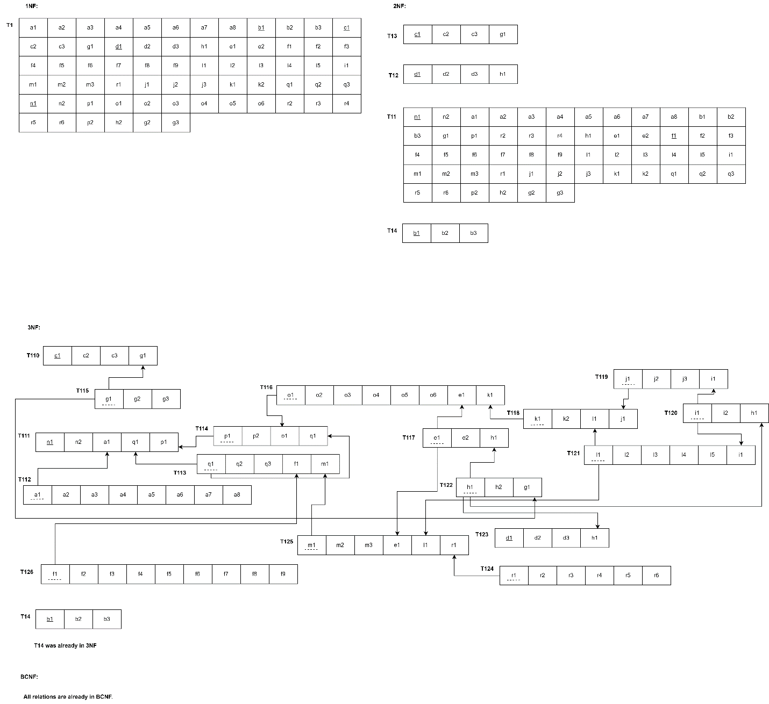

## DATA DICTIONARY:

School_T

|  |  |  |  |
| --- | --- | --- | --- |
| Name | Data Type | Size | Remarks |
| cSchoolID | VARCHAR | 5 | This is the primary key of School.  E.g.: “SETS” |
| cSchoolName | VARCHAR | 50 | This is the name of the school.  E.g.: “School of Engineering, Technology & Science”. |

Program_T

|  |  |  |  |
| --- | --- | --- | --- |
| Name | Data Type | Size | Remarks |
| cProgramID | INTEGER |  | This is the primary key for a program. E.g.: “1” |
| cProgramName | VARCHAR | 50 | This is the name of the program.  E.g.: “Bachelor of Science” |
| cDepartmentID | VARCHAR | 3 | This is the foreign key from the Department table.  E.g.: “CSE” |

Department_T

|  |  |  |  |
| --- | --- | --- | --- |
| Name | Data Type | Size | Remarks |
| cDepartmentID | VARCHAR | 3 | This is the primary key for the  Department table.  E.g.: “CSE” |
| cDepartmentName | VARCHAR | 50 | This is the name of the department.  E.g.: “Computer Science and Engineering”. |
| cSchoolID | VARCHAR | 5 | This is a foreign key from the school table.  E.g.: “SETS”. |

CLO_T

|  |  |  |  |
| --- | --- | --- | --- |
| Name | Data Type | Size | Remarks |
| nCLOID | INTEGER |  | This is the primary key for the CLO table.  E.g.: “1”. |
| cCLONum | TEXT |  | E.g.: “CLO1”. |
| nThreshold | Integer |  | It is the minimum marks needed to pass  E.g., “40” |
| cPLOID | INT |  | This is the foreign key from the Program Learning Outcome table.  E.g.: “PLO1” |
| cCourseID | VARCHAR | 6 | This is the Foreign Key from the Course table.  E.g.: “CSE203” |

PLO_T

|  |  |  |  |
| --- | --- | --- | --- |
| Name | Datatype | Size | Remarks |
| cPLOID | VARCHAR | 5 | This is the primary key for Program Learning Outcome.  E.g.: “PLO1” |
| nPLONum | INTEGER |  | This is the PLO number. E.g.: “1” |
| cDetails | VARCHAR | 50 | These are the details for Program Learning Outcome. E.g.: “An ability to select and apply the knowledge, technique, skills and modern tools of the computer science and engineering discipline” |
| cProgramID | INTEGER |  | This is the foreign key from the program table.  E.g.: “1” |

Evaluation_T

|  |  |  |  |
| --- | --- | --- | --- |
| Name | Datatype | Size | Remarks |
| nEvaluationID | INTEGER |  | This is the Primary Key for Enrollment. |
| cObtainedMarks | NUMBER |  | This is the obtained marks of the student.  E.g.: “24.5” |
| cQuestionID | INTEGER |  | This is the foreign key from the  assessment table. |
| nRegistrationID | INTEGER |  | This is the Foreign Key from Registration table. |

Student_T

|  |  |  |  |
| --- | --- | --- | --- |
| Name | Data Type | Size | Remarks |
| nStudentID | INTEGER |  | This is the primary key for the student table.  E.g.: “1921834”. |
| cFirstName | VARCHAR | 30 | This is the first name of the student.  E.g.: “Rakibul”. |
| cLastName | VARCHAR | 30 | This is the last name of the student.  E.g.: “Hasan”. |
| dDateOfBirth | DATE | DD  MM  YYYY | This is the birth date of the student.  E.g.: “21-12-1996”. |
| cGender | VARCHAR | 6 | This is the gender of the student.  E.g.: “Female”. |
| cEmail | VARCHAR | 30 | This is the email of the student.  E.g.: “1921834@iub.edu.bd” |
| nPhone | NUMERIC | 11 | This is the phone of the student.  E.g.: “01XXXXXXXXX”. |
| cAddress | VARCHAR | 50 | This is the address of the student.  E.g.: “House 1,  Road 4, Block D, Bashundhara RA”. |
| dEnrollmentDate | DATE | DD  MM  YYYY | This is enrollment date of the student.  E.g.: “1-1-2019” |
| cProgramID | INTEGER |  | This is the foreign key from the program table.  E.g.: “1” |
| cDepartmentID | VARCHAR | 3 | This is the foreign key from the Department table.  E.g.: “CSE” |

Employee_T

|  |  |  |  |
| --- | --- | --- | --- |
| Name | Datatype | Size | Remarks |
| nEmployeeID | INTEGER |  | This is the primary key for Employee table.  E.g.: “1801” |
| cFirstName | VARCHAR | 30 | This is the first name of the faculty.  E.g.: “Sadita” |
| cLastName | VARCHAR | 30 | This is the last name of the faculty.  E.g.: “Ahmed” |
| dDateofbirth | DATE | DD-MM YYYY | This is the date of Birth of the faculty.  E.g:01-01-1992 |
| cGender | VARCHAR | 6 | This is the gender of the faculty.  E.g.: “Female” |
| cEmail | VARCHAR | 30 | This is the email address of the student.  E.g.: “1675231@iub.edu.bd” |
| nPhone | NUMERIC | 11 | This is the phone number of the faculty.  E.g.: “01292383111” |
| cAddress | VARCHAR | 30 | This is the address of the faculty.  E.g.: “House 14, Road 21, Sector 11, Baridara,Dhaka, Bangladesh” |
| cEmployeeType | CHAR | 1 | This is the type of employee.  E.g.: “F” |

 Course_T

|  |  |  |  |
| --- | --- | --- | --- |
| Name | Datatype | Size | Remarks |
| cCourseID | VARCHAR | 6 | This is the Primary Key for the Course.  E.g.: “CSE203” |
| cCourseName | VARCHAR | 40 | This is the name of the Course.  E.g.: “Discreet Mathematics” |
| nNumOfCredits | INTEGER |  | This is the number of credits for the Course.  E.g.: “3” |
| cCourseType | VARCHAR | 10 | This is the type of the Course. E.g.: “Core” |
| cPLOID | INTEGER |  | This is the foreign key from the Program Learning Outcome table.  E.g.: “PLO1” |

Section_T

|  |  |  |  |
| --- | --- | --- | --- |
| Name | Datatype | Size | Remarks |
| nSectionID | INTEGER |  | This is the Primary Key for Section.  E.g.: “1” |
| nSectionNum | INTEGER |  | This is the section number.  E.g.: “1” |
| cCourseID | VARCHAR | 6 | This is the foreign key from the Course table.  E.g.: “CSE101” |
| cSemester | VARCHAR | 6 | This is the semester of the section.  E.g.: “Summer” |
| cFacultyID | NUMERIC | 4 | This is the foreign key from Faculty table.  E.g.: “1801” |
| dYear | YEAR | yyyy | This is the year of registration.  E.g.: “2019” |

Registration_T

|  |  |  |  |
| --- | --- | --- | --- |
| Name | Datatype | Size | Remarks |
| nRegistrationID | INTEGER |  | This is the Primary Key for Registration.  E.g.: “0101010101” |
| cSemester | VARCHAR | 6 | This is the semester of registration.  E.g.: “Spring” |
| dYear | YEAR | yyyy | This is the year of registration.  E.g.: “2019” |

Question_T

|  |  |  |  |
| --- | --- | --- | --- |
| Name | Datatype | Size | Remarks |
| nQuestionID | INTEGER |  | This is the Primary Key for  Assessment. |
| cAssessmentName | VARCHAR | 30 | This is the name of the assessment.   E.g.: “Mid” |
| cTotalMarks | NUMBER |  | This is the total marks of the assessment.  E.g.: “30” |
| cQuestion | VARCHAR |  | This is the question for the assessment.  E.g.: “What is SQL” |
| nQuestionNum | INTEGER |  | This is the question number  E.g.: “1,2,3….” |
| nWeight | INTEGER |  | This is the percentage range for assessment.  E.g.: “Project- 50%, Assessment-50%”. |
| nSectionID | INTEGER |  | This is the Foreign Key from Section table. |
| nCOID | INTEGER |  | This is the Foreign Key from the Course Outcome table. |

Faculty_T

|  |  |  |  |
| --- | --- | --- | --- |
| Name | Datatype | Size | Remarks |
| nFacultyID | INTEGER |  | This is the primary key for the faculty table.  E.g.: “4250” |
| dJoinDate | DATE | dd-mm yyyy | This is starting date.  E.g.: “01-03-2020” |
| cRank | VARCHAR | 30 | This is the rank of the faculty.   E.g.: “Assistant Professor” |
| cDepartmentID | VARCHAR | 3 | This is the foreign key from the Department table.  E.g.: “CSE” |

Admin_T

|  |  |  |  |
| --- | --- | --- | --- |
| Name | Datatype | Size | Remarks |
| nAdminID | INTEGER |  | This is the primary key for the admin table.  E.g.: “4250” |
| cAdminType | VARCHAR | 30 | This is the type of user logging in  E.g.: “VC” |
| dJoinDate | DATE | dd-mm yyyy | This is starting date.  E.g.: “01-03-2020” |
| cRank | VARCHAR | 30 | This is the rank of the admin.  E.g.: “Assistant Professor” |
| dEndDate | DATE | dd-mm  yyyy | This is the date the admin retires from his post.  E.g.: “01-03-2024” |
| cDepartmentID | VARCHAR | 3 | This is the foreign key from the Department table.  E.g.: “CSE” |
| cSchoolID | VARCHAR | 5 | This is a foreign key from the school table.  E.g.: “SETS”. |

Course_Outline_T

|  |  |  |  |
| --- | --- | --- | --- |
| Name | Datatype | Size | Remarks |
| nCourseOutlineID | INTEGER |  | This is the Primary Key for  Course Outline. |
| cCourseDescription | TEXT |  | This is the description of the course   E.g.: “Basic concepts of DBMS.” |
| cAssessmentAndMarksDistribution | TEXT |  | This is the total marks distribution of the course.  E.g.: “Final-100” |
| cGradeConversionScheme | TEXT |  | This is the breakdown of which grade carries which score  E.g.: “A-4.00” |
| cRequiedTextbook | TEXT |  | This is the list of the books required for the course  E.g.: “Modern Database Management by Jeffrey A. Hoffer, Mary B. Prescott, Fred R. Mcfadden.” |
| cCourcePolicy | TEXT |  | These are the policies of a course  E.g.: “No working mobile phones are allowed in class.” |
| cUniversityRegulationAndCodeOfConduct | TEXT |  | These are the rules given by the university that must be maintained.  E.g.,” Please see the Green Book for further information” |
| nSectionID | INTEGER |  | This is the Foreign Key from Section table. |

Backlog_Records_T

|  |  |  |  |
| --- | --- | --- | --- |
| Name | Datatype | Size | Remarks |
| Timestamps | DATETIME | yyyy-mm-dd | Here ‘Timestamps’ is generating DATETIME datatype, where it is containing the data of entry log of backlog data. |

# CHAPTER-4 PHYSICAL SYSTEM DESIGN

## STARTUP PAGE:

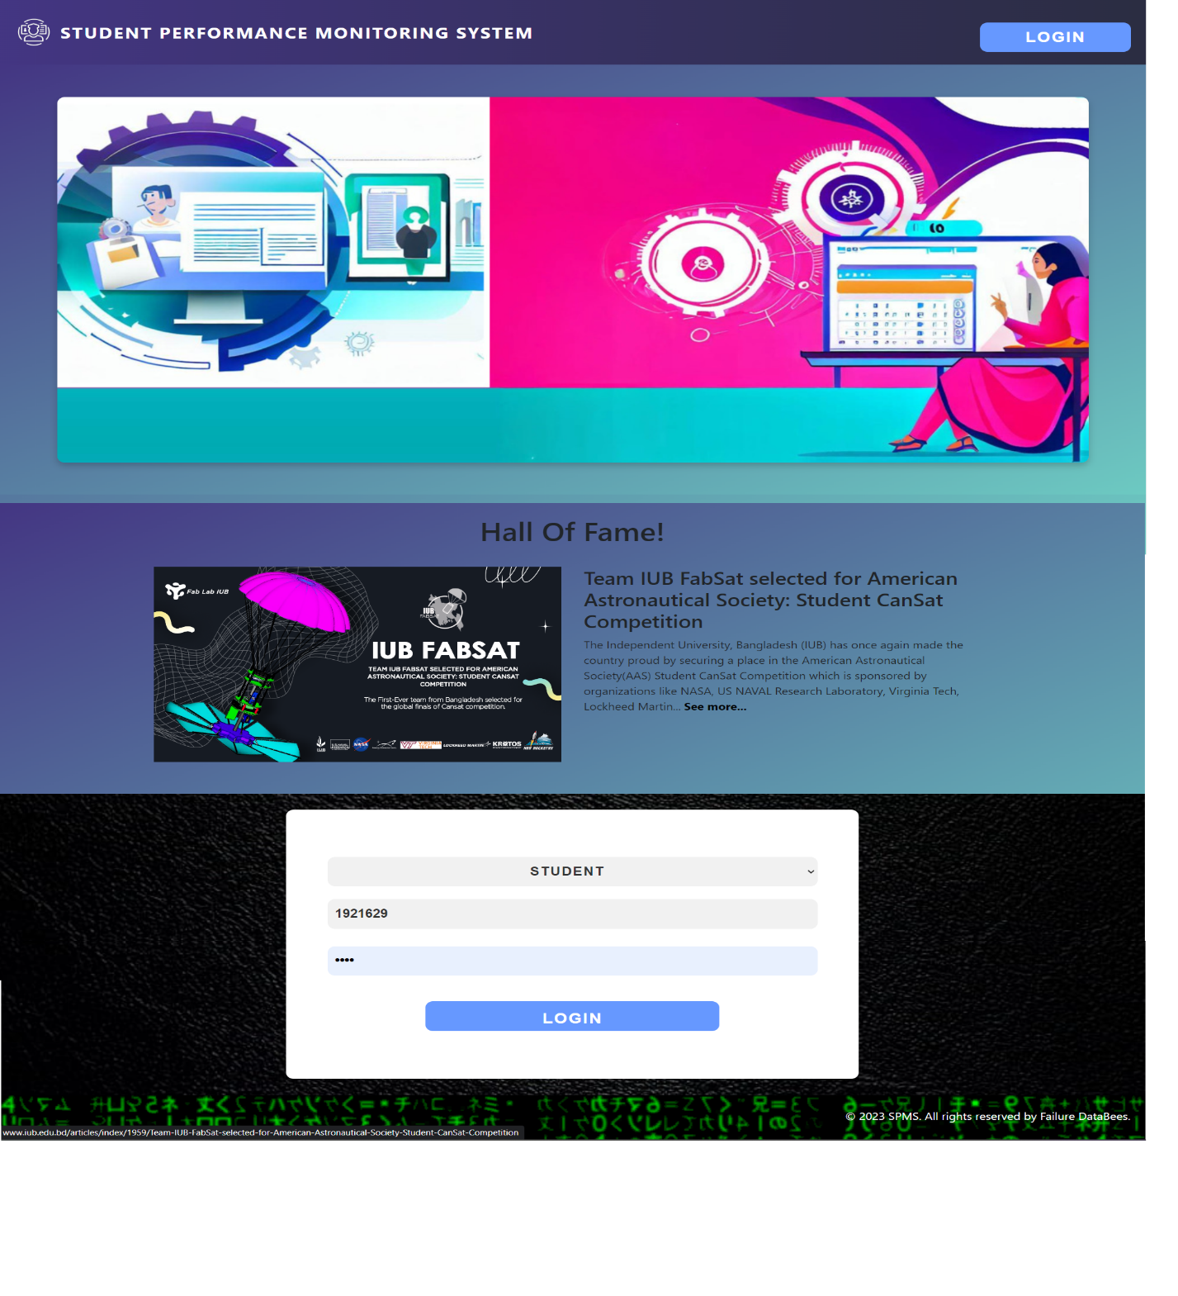

## Backlogged Student Data Entry Form

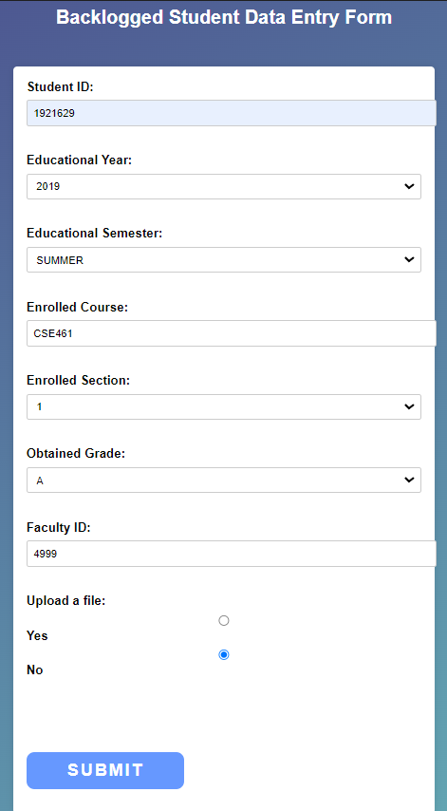

## Backlogged Students Data Table:

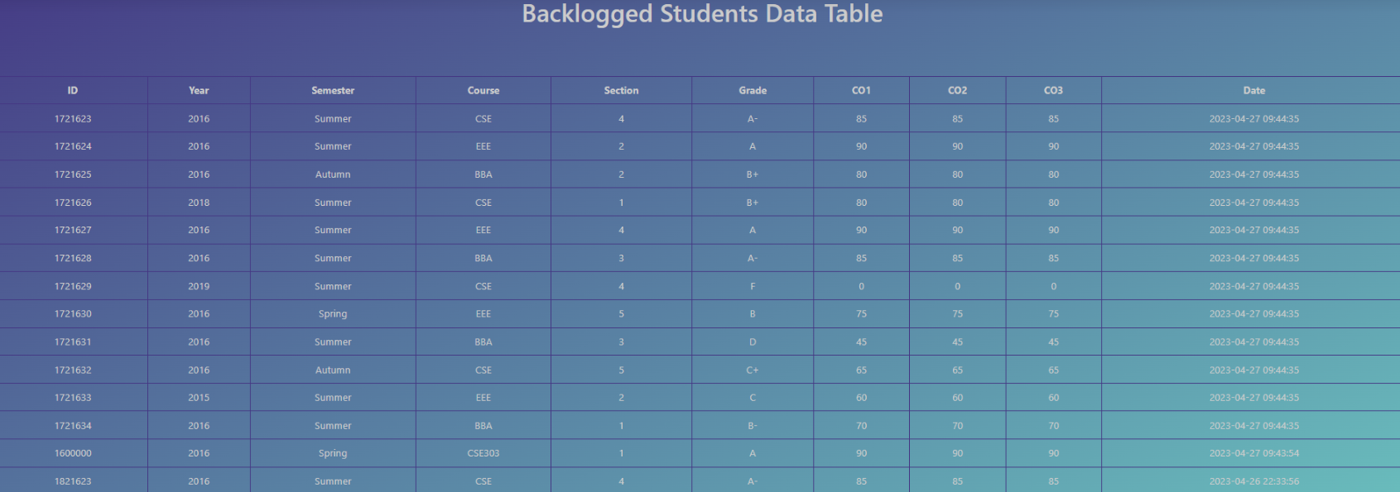

## Add exam data entry form:

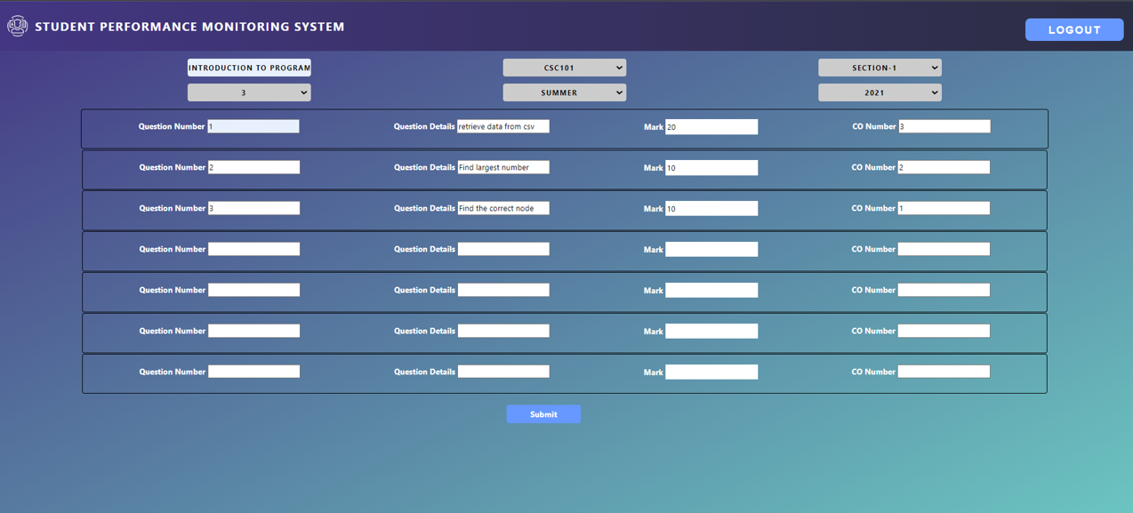

## PLO Analysis Spider Chart:

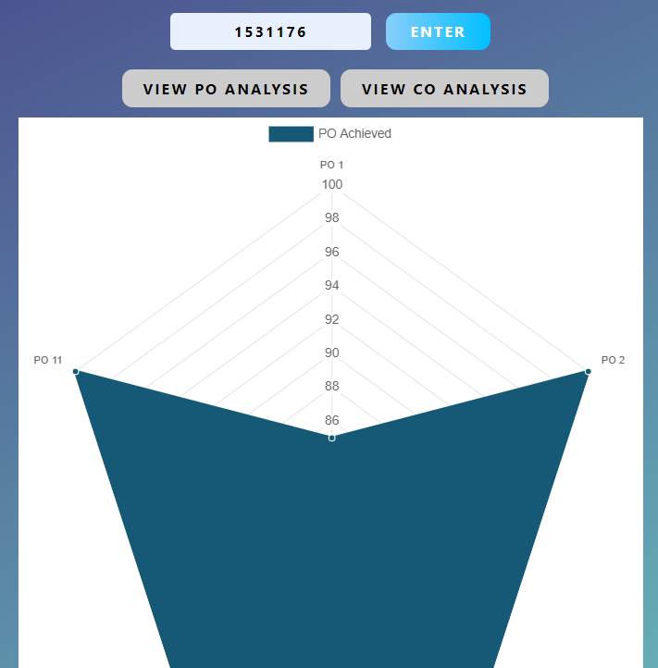

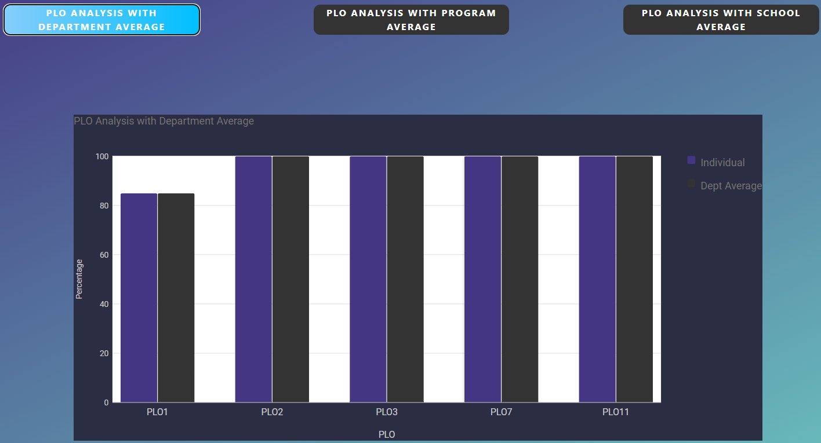Plo Analysis with Department Average Bar Chart:

## Code For Backlogged Data Retrieving from CSV And Inserting Into Section Table, Registration Table & Student Course Performance Table For Updating PLO, CLO Analysis:

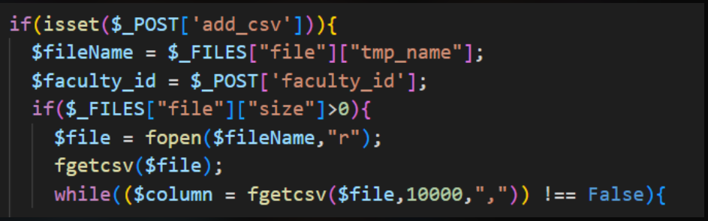

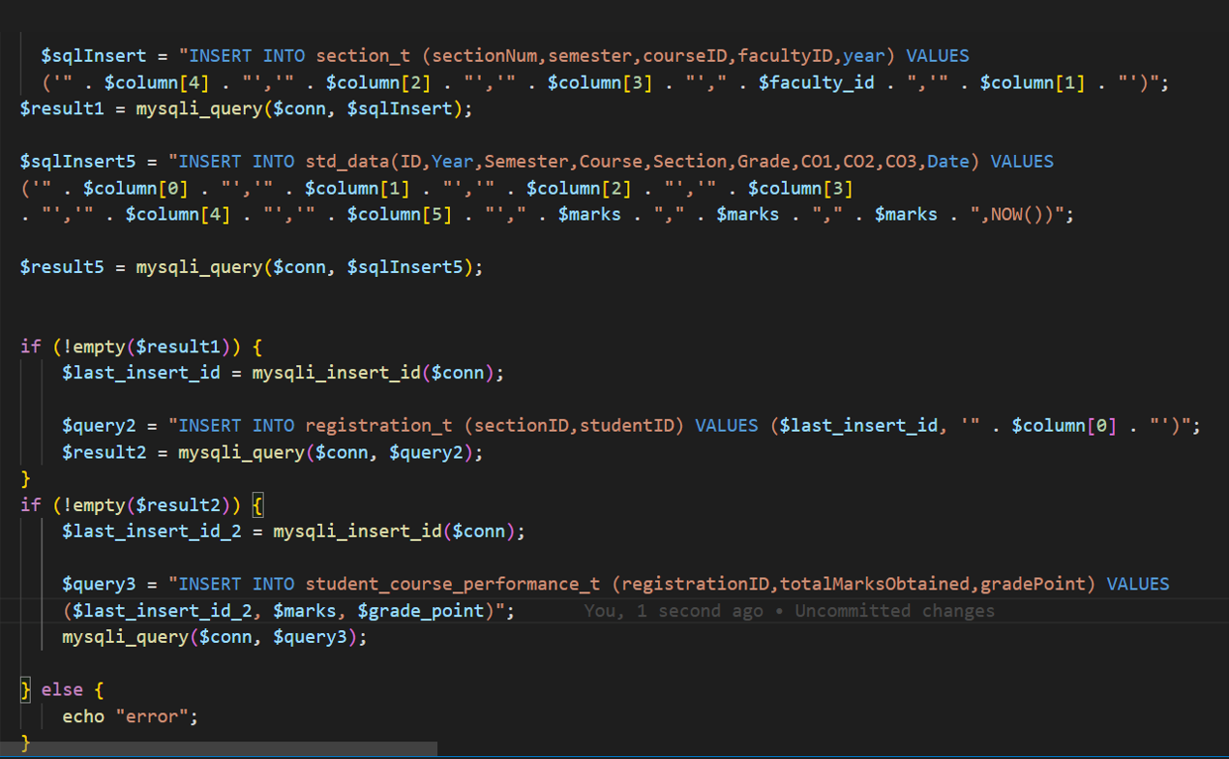

Code for Showing Backlogged Data Table: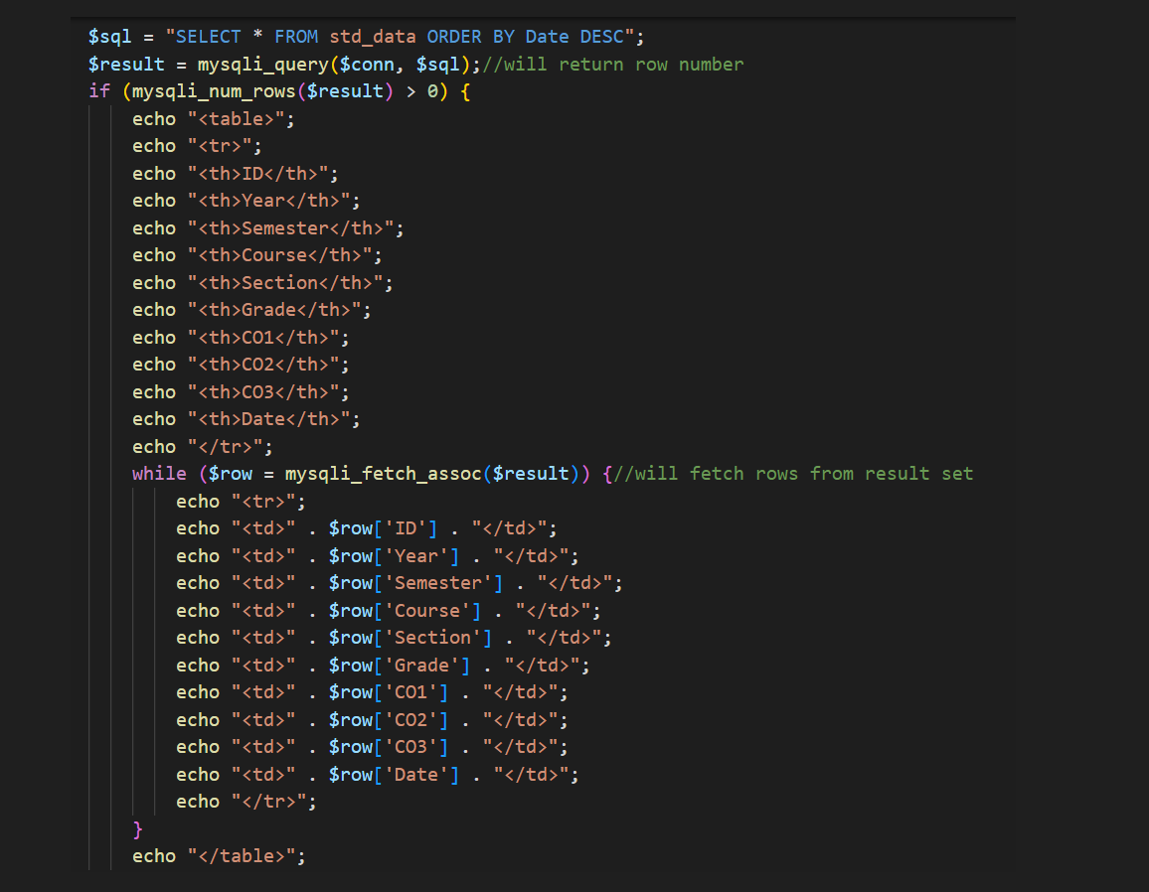

# CHAPTER-5 CONCLUSION

## PROBLEM AND SOLUTION:

### Analysis Phase:

During the Analysis Phase, a significant challenge encountered was the lack of data on the organizational operations, which led to confusion regarding the Rich Picture and Six Element Analysis. In order to address this issue, interviews were conducted with Faculty members and other stakeholders to clarify the operations and gather relevant information. The data collected from these interviews was then utilized to gain a more comprehensive understanding of the system being developed.

### Design Phase:

Challenges arose during the Design Phase when creating the EERD and Relational Schema, but they were successfully resolved with the help of continuous feedback from faculty members. Their input proved valuable in overcoming the issues encountered during the design process.

### Implementation Phase:

All the System Requirements were completed successfully.

Front-End Developing tools: HTML, CSS, JavaScript, Google Bar Charts, Chart JS

Back-End Developing tools: PHP, JSON

Database-integration: MySQL

### Additional Features and Future Development:

One new feature could be added to this system in the near future which can monitor a student's extracurricular activities and then provide reports and analytics based on the student's extracurricular activity performance.

### Conclusion & Recommendations

We believe that our idea for an SPM software has been developed and implemented in the best possible way. Our goal is to enhance the quality of education offered by institutions through the effective utilization of this software. This program can benefit students who strive to become proficient scholars, faculties who wish to keep track of their students' progress and adapt their teaching techniques accordingly, as well as institutional members who aim to manage their resources more efficiently.